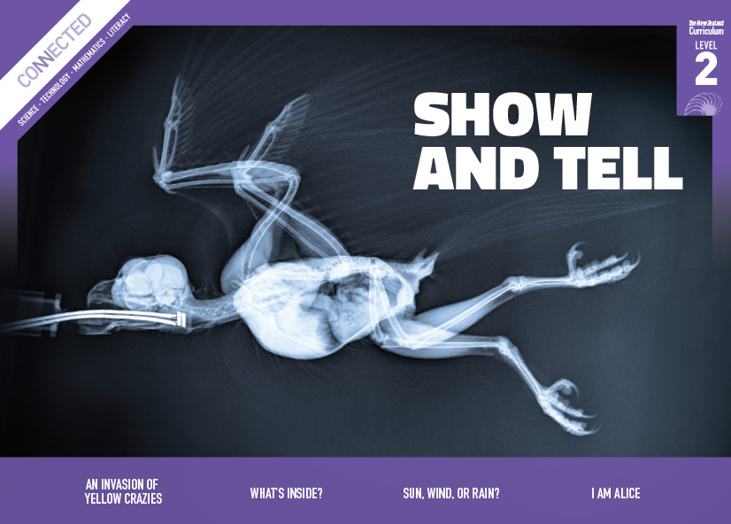
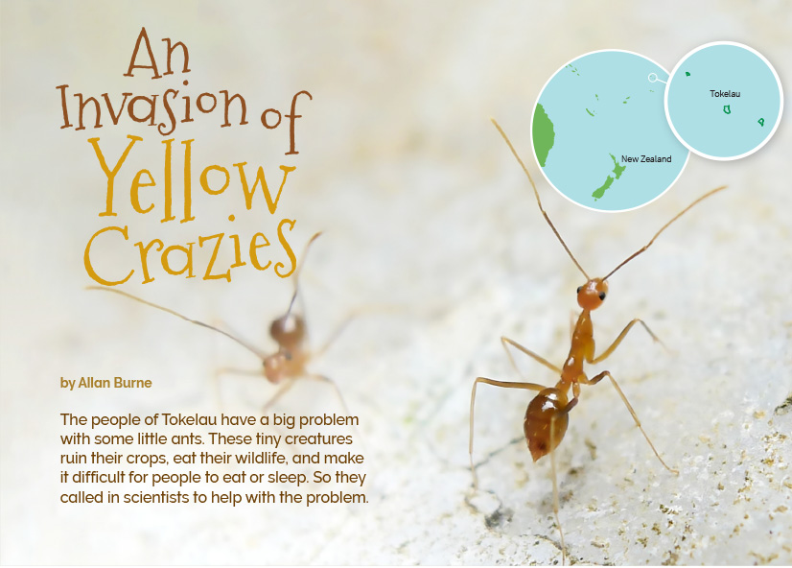
Connected
Level 2
2016

An Invasion of Yellow Crazies
by Allan Burne

Overview
This article describes how scientists investigated yellow crazy ants, which had invaded the islands of Tokelau, causing major problems. It demonstrates how data is collected and recorded so that science can identify the extent of a problem and can then inform options for addressing the problem.
A Google Slides version of this article is available at www.connected.tki.org.nz.

Curriculum contexts

SCIENCE: Nature of Science: Communicating in science  Achievement objective  Level 2 – Build their language and develop their understandings of the many ways the natural world can be represented. | Key Nature of Science ideas  Scientists:  - ask questions and collect data to answer these questions  - use tables, charts, and graphs to present data gathered from scientific investigations  - use diagrams or models to communicate science ideas.
SCIENCE: Living World: Ecology  Level 2 – Recognise that living things are suited to their particular habitat. | Key science ideas  - Living things depend on one another and on the non-living environment in which they live.  - Living things need a suitable environment to provide them with food and shelter.  - Changes in the population of one species in one environment may affect other species in that area.
ENGLISH: Reading  Level 2 – Ideas: Students will show some understanding of ideas within, across, and beyond texts. | Indicators  - Uses their personal experience and world and literacy knowledge to make meaning from texts.  - Makes meaning of increasingly complex texts by identifying main ideas.  - Makes and supports inferences from texts with some independence.

The New Zealand Curriculum

Science capability: interpret representations

Capability overview
Scientists represent their ideas in a variety of ways. They might use models, graphs, charts, diagrams, photographs, and written text. A model is a representation of an idea, an object, a process, or a system. Scientists often use models when something is not directly observable. Models enable scientists to work on their ideas, even though they are often using a limited representation of the “thing” itself. It is important students can identify what is the same and what is different about the model and the thing. | It is important for students to think about how data is presented and ask questions such as:  What does this representation tell us?  What is left out?  How does this representation get the message across?  Why is it presented in this particular way?  This sort of questioning provides a foundation to critically interact with ideas about science in the media and to participate as critical, informed, and responsible citizens in a society where science plays a significant role.

More about the capability

The capability in action
The science capability “Interpret representations” is about students understanding information that is presented as a description or in visual form and recognising the best way to present information.  Scientific representations include diagrams, models, charts, and graphs, as well as written text.  Scientists develop models and diagrams that best represent their theories and explanations.  Scientists  Scientists use:  - representations that can help both the original scientist and others clarify, critique, and evaluate their ideas, research, and theories  - computer and other kinds of modelling to predict what might happen in certain conditions and then test these predictions to see how accurate the model or idea is  - diagrams or models to communicate science ideas  - graphs to present data  - scientific forms of text involving argumentation that use evidence to debate explanations.  Students  Students should have opportunities to:  - learn to interpret a variety of representations, including models, diagrams, graphs, and text  - develop their own representations of scientific ideas, for example, through modelling using concrete materials or using their own bodies in mime and drama  - recognise how the representation matches the idea and how it is different  - consider and critique a range of representations, including scientific texts, newspaper articles about scientific matters, online information about science matters, and scientific representations developed by their peers. | Teachers  Teachers can:  - help students to be more critical consumers of science information by being explicitly critical themselves and modelling useful questions  - support students to evaluate how information is presented, for example, to assess if a graphical presentation has been done appropriately or is misleading  - ask questions such as:  - What do you think this representation tells us?  - What do the (arrows, lines, symbols, etc.) mean? (that is, helping your students interpret the features)  - Is anything left out? Do you think anything is missing from the representation?  - How does this get the message across?  - Is there anything more you need to know to be able to interpret this representation?  - How does the representation make the science idea clear?  - Which aspects of this representation could mislead the reader?  - Why is it presented in this way?  - Could you suggest a better way to represent it?  - establish a science classroom culture by:  - modelling and encouraging a critical stance  - encouraging students to consider the quality and interpretation of scientific representations  - having learning conversations that involve interpreting, critiquing, and developing representations to demonstrate the idea’s relevance in everyday life.

More activities to develop the capability

Meeting the literacy challenges

The literacy demands of the text require students to understand the different ways that scientists record and represent scientific information, including:  - descriptions in running text  - content specific vocabulary  - diagrams with labels and captions  - a bulleted list describing the damage caused by ants.  Tally charts and card counts represent two different ways of collecting and interpreting data, and a list of possible solutions are described at the end of the article. Headings provide support. | The following strategies will support students to understand, respond to, and think critically about the information and ideas in the text.  You may wish to use shared or guided reading, or a mixture of both, depending on the reading expertise of your students and the background knowledge they bring to the text.  After reading the text, support students to explore the activities outlined in the following pages.

INSTRUCTIONAL STRATEGIES

Finding the main ideas  tell the students the title and have them make predictions about the kinds of information they will find in the text. Then have them SCAN the text, using the headings and images to check their predictions and get a sense of the author’s purpose. PROMPT them to notice that the scientists were helping the people of Tokelau by conducting an experiment to find out more about the crazy ants that were making their lives difficult.  If the students have difficulty with the word “invasion”, unpack it before reading on.  The word “invasion” comes from the word “invade”. You will find that the author has also used the words “invasive” and “invaders”. What do you think “invade” means? How does the meaning change when the ending changes? Let’s check our ideas in a dictionary.  Have the students read the first page. PROMPT them to notice how the author engages the reader by playing with language, focusing attention on the central issue, and getting across a lot of information.  The title of this article sounds like the name of a horror film. Why do you think the author did that? What impact did it have on you as a reader?  The author writes, “The people of Tokelau have a big problem with some little ants.” Why do you think the author used this sentence in the introduction?  DISCUSS the steps of a typical scientific investigation. Using what they know and what they have noticed about the text, support the students to construct a summary table. Model how to use the headings to summarise the stages these scientists worked through. | The process Investigation into yellow crazy ants in Tokelau  Decide on the question  Design an investigation to help answer the question  Collect and record data  Analyse data  Draw conclusions  Make recommendations  Have the students read the rest of the test, then support them as they work in groups to complete their summary tables. EXPLAIN that their goal is to make their summaries as succinct as possible, while capturing the main ideas. They can use written text, but they can also use other means of conveying the information, such as sketches or diagrams. When they have finished, the groups can evaluate each other’s summaries.  Would someone who has not read the article get the main points from this summary?  Have all the main points been captured? How clear are they?  Where have sketches or diagrams been more helpful than just written words? Why do you think this is?  DISCUSS the options the scientists identified for managing the ants. Have the students use the information in the text and their own thinking to make a chart of the options, explaining the positive and negative aspects of each option.  Option Positives Negatives  Option 1:  Option 2:  Option 3:  Option 4:

Meeting the literacy challenges

Using maps and diagrams to deepen understanding  Prior to reading, PROMPT the students to notice the variety of ways information is communicated in this article.  Use the map on page 2 to help the students locate Tokelau. After reading page 3, you might also use a map of the world to reinforce the information about how yellow crazy ants have spread. Alternatively, you could use a globe and to convey the idea of “globalisation”.  After the students have read the first two pages, have them COMPARE the photo of the yellow crazy ant on page 2 with the written description and with the diagram of the anatomy of an ant on page 3.  What is the same? What is different?  How good a picture would you have got of the ants from the words alone?  What can you see in the photo that you can’t see in the diagram? What does the diagram show that can’t be seen in the photo? What is the purpose of the diagram?  Think about how each of these ways of communicating information is useful.  PROMPT the students to unpack the representation of the ants’ life cycle on page 4.  What do the arrows represent?  How does the diagram show that there are three different kinds of adult ant?  What does the arrow between the queen ant and the egg mean? How is its meaning different from the other arrows? [The queen lays an egg that hatches into a new ant. The other arrows represent the same ant changing its form.]  Note that a common misconception is that the egg, larvae, and adult forms of insects are different animals, rather than the same animal changing form at different times in its life. | PROMPT the students to extract information from the illustration of the lure on page 6.  What evidence can you see that the ants prefer sugar water?  ASK the students to look closely at the cross-section of a pitfall trap on page 7.  What can you see?  What do you think “cross-section” means?  Why do you think the author used a cross-section to show the pit trap?  How does the cross-section help you understand how the trap works? DISCUSS the data table of ant species on page 7. If the students do not already know the term “data table”, introduce it now. Point out the way the data is organised into rows and columns with subheadings and demonstrate how the table could be converted into a graph, with an x- and a y-axis. Which headings represent the x-axis? Which represent the y-axis?  What patterns do you notice in the data?  Which do you find easier to read – a table or a graph? Why?  If you were to graph this data, would it be better to use a line graph or bar graph? Why do you think that?  REVIEW the tables and graphs, comparing how clearly they represent the data.  What are the advantages of tables?  What are the advantages of graphs?

Reading standard: by the end of year 4
The Literacy Learning Progressions
Effective Literacy Practice: years 1–4

Meeting the literacy challenges

TEACHER SUPPORT
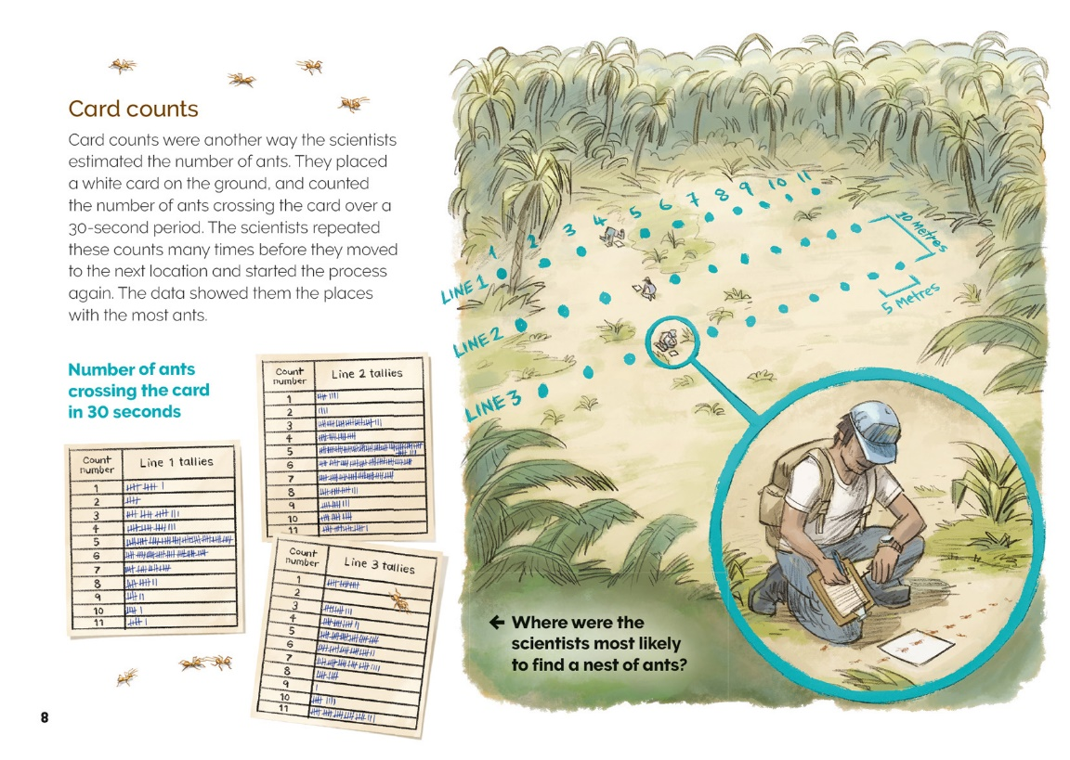  Scientists ask questions and collect data to answer these questions. |  | Scientists use diagrams or models to communicate science ideas.
Scientists use tables, charts, and graphs to present data gathered from scientific investigations. | [Grab your reader’s attention with a great quote from the document or use this space to emphasize a key point. To place this text box anywhere on the page, just drag it.]

Learning activities – Exploring the science
The following activities are a guide for supporting students to explore and develop understandings about the science capability “Interpret representations”. Some activities focus directly on the science capability. Other activities extend student content knowledge across the learning areas. Adapt these activities to support your students’ learning needs.

Activity 1 – Globetrotting pests
The article explains that the ants “hitchhike their way over oceans, hiding in the food, machinery, and building supplies that are shipped around the world”. Ask the students if they know of other invasive species and what measures are used to prevent them spreading. Students may have seen the television programme Border Patrol, and those who have travelled overseas, will be able to share their experiences of border security. Some may have experienced biosecurity threats, such as when fruit flies were discovered in Grey Lynn.
Play the MPI in-flight video that sets out the requirements for people entering New Zealand. The video is short and tells people what they must do. Talk about the importance of border security and what the students learnt from the article. For more about the concept of border security, see Connected 3, 2011.
Explain that some people find border regulations annoying. They think it’s silly that they can’t take a piece of fruit into a country. Other people forget that they have fruit in their bags. But when they understand the reasons for the regulations, they are more likely to take them seriously.
Set the students the task of persuading an audience to obey border security regulations when re-entering New Zealand after an overseas trip. They are to do this by:
- selecting a pest that has invaded a country where it did not belong
- describing the pest, using photos and labelled diagrams
- explaining why it is a problem and supporting this with evidence
- explaining how the country has dealt with the pest.
The students will need to think about how they can present the information to be as persuasive as possible. They could work in groups, each focused on a particular pest, either in New Zealand or overseas. Some may want to continue with yellow crazy ants and look at their impact in other parts of the world, such as on the crabs on Christmas Island. Others may like to focus on a pest invasion in New Zealand. Note that the resource links include information about invasive plants, as well as invasive animals.

Extending the learning
Connect this discussion to the future-focus theme of globalisation and the impact of new technologies. Our ability to move people and products around the world has many benefits, but is it worth it if we end up ruining our ecosystems? Have the students debate the pros and cons of these changes in our world. Can they be managed or do we need to slow down?

Activity 2 – Investigating pests in our own environment
The scientists in Tokelau identified a problem, constructed a method for finding out more about the problem, and then considered possible solutions. This happens in New Zealand at a national, regional, and local level. This activity moves students through a series of activities at each of these levels. You may wish to do them all or you may prefer to focus at one level only.

Pests at our school
Students might be keen to carry out a hands-on experiment at school.
What pest have you noticed at our school?
How could we find out more about it?
How might we collect our data?
There is a link to instructions for investigating pests at school on the Department of Conservation website. The students may also like to design their own traps. Tracking tunnels and chew-track cards are easy to design and make.
The students should follow a similar method to the scientists in Tokelau, recording their data on tally sheets, organising the data, and then asking questions of their data.
What patterns do you notice?
Do they confirm that there is a problem?
If there is a problem, can we do something about it? If so, what?
The students may like to make a presentation to the school assembly or board of trustees about the pest and how it could be reduced, or they could set up a web page to encourage local people to help eradicate the pest.

Pests in our local environment
Few parts of New Zealand are free from invasive pests. In many instances, the Regional Council, Department of Conservation, and/or local volunteer groups are investigating the problem and designing solutions. The solutions include weeding, revegetating, poisoning, trapping, using biological controls, and setting up sanctuaries. You can make contact with local groups by going to the “Get involved” section of the Department of Conservation’s website and opening the sub-section on volunteer activities.

Learning activities – Exploring the science

Activity 2 (continued)
You could invite an expert to talk to the class about their work. Before your visitor arrives, explain to the students that they will write a report on the science behind the activity after the presentation. Explain that they are to use headings that are similar to the ones they used to summarise the investigation in Tokelau. To do this, they need to prepare a list of questions for the visiting expert about the target pest, the information that has been collected, how it has been collected, what has been learned, and what is being done.  Brief your visitor so that they are prepared for the sorts of questions the students will ask. Encourage them to bring supporting material, such as photos, tally sheets, and samples of pest plants and animal traps. Ideally, arrange for the students to go on-site and see what is being done – and perhaps help out.  Have the students write their reports and use what they have discovered to inform others in the community about the pest management operation. | Pests in New Zealand  The resource links provide options for finding out more about pests in New Zealand. Groups of students could focus on a particular pest. Have students collect diagrams and illustrations of the pest to see which are most useful for identifying it. They could do online research and summarise their findings, using a summary table like the one they used to summarise the main ideas in the article. The links are to articles about buddleia, and the Argentine ant, but students may also wish to research other pests. This background information could then be shared and used to help control pests in the local environment.  Consider the practicalities of your students investigating animal pests. Young students can identify and carry out activities to rid their local environment of plant pests more easily than animal pests.

RESOURCE LINKS

Building Science Concepts  Book 4: Animal Life Histories: Reproduction, Growth, and Change (examines different life cycles and reproduction)  Book 39: Is This an Animal?: Introducing the Animal Kingdom (explores the way scientists group and classify living things)  Connected  “Border Security – Keeping New Zealand Pest and Disease Free”, Connected 3, 2011 and TSM  Science Learning Hub  Biosecurity: http://link.sciencelearn.org.nz/topics/biosecurity  Managing invasive plants: http://link.sciencelearn.org.nz/resources/427-river-islands  Weevils as biological control: http://link.sciencelearn.org.nz/resources/1578-weevils-eat-pesky-buddleia-weeds  Irish wasp to the rescue: http://link.sciencelearn.org.nz/resources/1739-irish-wasp-to-the-rescue  Bio-control: http://link.sciencelearn.org.nz/topics/biocontrol  http://link.sciencelearn.org.nz/resources/1743-biocontrol  Bio-control in action: http://link.sciencelearn.org.nz/resources/1742-biocontrol-in-action-unit-plan  Biocontrol of the New Zealand pea crab: http://link.sciencelearn.org.nz/resources/758-biocontrol-of-the-new-zealand-pea-crab | Other sources on yellow crazy ants  Christmas Island Yellow Crazy Ant Control Program: www.environment.gov.au/system/files/resources/898583db-b929-491a-8448-73fb652bca66/files/brochure-detail-crazy-ant-control-options.pdf  Invasive species compendium – yellow crazy ant: www.cabi.org/isc/datasheet/5575  Saving seabirds from an island invasion: http://usfwspacific.tumblr.com/post/67589291621/saving-seabirds-from-an-island-invasion  New Zealand Herald article “Bug-busting Kiwis helping to stamp out ‘crazy’ ant”: www.nzherald.co.nz/technology/news/article.cfm?c_id=5&objectid=11462940  ‘Yellow Crazy Ants’ threaten Christmas Island Crabs (video is 52 minutes long): www.youtube.com/watch?v=pXJdNKiw8Ps  Department of Agriculture and Fisheries (Queensland, Australia): www.business.qld.gov.au/industry/agriculture/species/declared-pests/animals/yellow-crazy-ant  Factsheet: www.daf.qld.gov.au/__data/assets/pdf_file/0011/76637/ipa-yellow-crazy-ants-pa28.pdf  Other sources about guarding against invasive species in New Zealand  Ministry for Primary Industries – Protection & response: www.mpi.govt.nz/protection-and-response/finding-and-reporting-pests-and-diseases/keeping-watch/  MPI – Border Control In-Flight Video: https://vimeo.com/153185344

Learning activities – Exploring the science

RESOURCE LINKS (continued)

Argentine ants in New Zealand  Resources for data gathering (Argentine ants):  http://argentineants.landcareresearch.co.nz/  www.doc.govt.nz/nature/pests-and-threats/animal-pests/animal-pests-a-z/argentine-ants/  www.biosecurity.govt.nz/pests/argentine-ant/control  www.biosecurity.govt.nz/pests/argentine-ant  www.stuff.co.nz/environment/74683629/New-poison-to-control-Argentine-ant-population-being-developed-in-Nelson  www.stuff.co.nz/nelson-mail/news/77169603/Developer-of-Argentine-Ant-poison-wants-council-coordinated-baiting  Landcare Research  Chew-track cards: www.landcareresearch.co.nz/science/plants-animals-fungi/animals/vertebrate-pests/pests-in-forests/chew-track-cards  Ants of NZ factsheet: www.landcareresearch.co.nz/publications/factsheets/Factsheets  www.landcareresearch.co.nz/resources/identification/animals/bug-id/what-is-this-bug  Weed Biocontrol Education Resources: www.landcareresearch.co.nz/science/plants-animals-fungi/plants/weeds/biocontrol/education | Department of Conservation  Tracking tunnels: www.doc.govt.nz/get-involved/conservation-activities/become-a-pest-detective/  Pests and threats: www.doc.govt.nz/nature/pests-and-threats/  Get involved: www.doc.govt.nz/get-involved/  Take a garden insect census: www.doc.govt.nz/get-involved/conservation-activities/take-a-garden-insect-census/

